Web-Technologies
(Assignment 2)

Submitted By | Fatima Khan.
Registration No | FA24-BCS-033.
Submitted To | Sir Usman Akram.
Date of Submission | 1st October’2026.

Assignment 2 — Your E-commerce Site: Static, Responsive Pages
Difficulty: Easy–Medium · Covers: Lectures 5–10 (CSS Fundamentals through Responsive Design and Frameworks) · Folder: assignment-2/
Task: Build the static, responsive front page and product page of your e-commerce site, modeled on your chosen reference site. No JavaScript yet — this assignment is entirely about layout, styling, and responsiveness.
You must build:
- A homepage / product listing page with a header (site name/logo, a nav bar, a cart icon that does not need to work yet) and a responsive grid of at least 8 product cards (image, name, price, an “Add to Cart” button that does not need to work yet).
- A single product detail page for one product: larger image, name, price, description, quantity selector, and an “Add to Cart” button (again, not functional yet).
- A consistent footer across both pages.
- The whole layout built with Flexbox and/or CSS Grid — no table-based layout, no absolute-positioning-everything.
- Genuine responsiveness: the layout must reflow sensibly at a phone width (~375px), a tablet width (~768px), and a desktop width, using media queries or your framework’s responsive grid classes. Screenshot all three widths for your completion PDF.
- Either Bootstrap or Tailwind (your choice) used for at least the grid/layout and the navbar — this is the frameworks half of Lecture 10, and it should actually be doing real work in your layout, not just be linked and unused.
Deliverables in assignment-2/: index.html, product.html, your CSS (or framework config), a README.md with your reference site’s name/URL/screenshot (see above), and your completion PDF.

Output:
HomePage: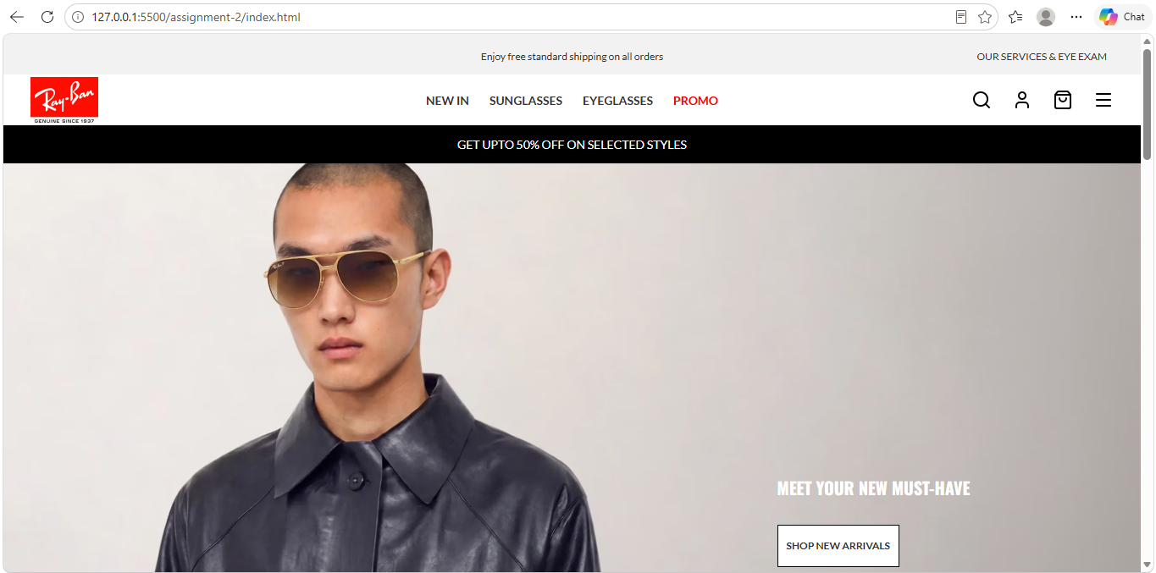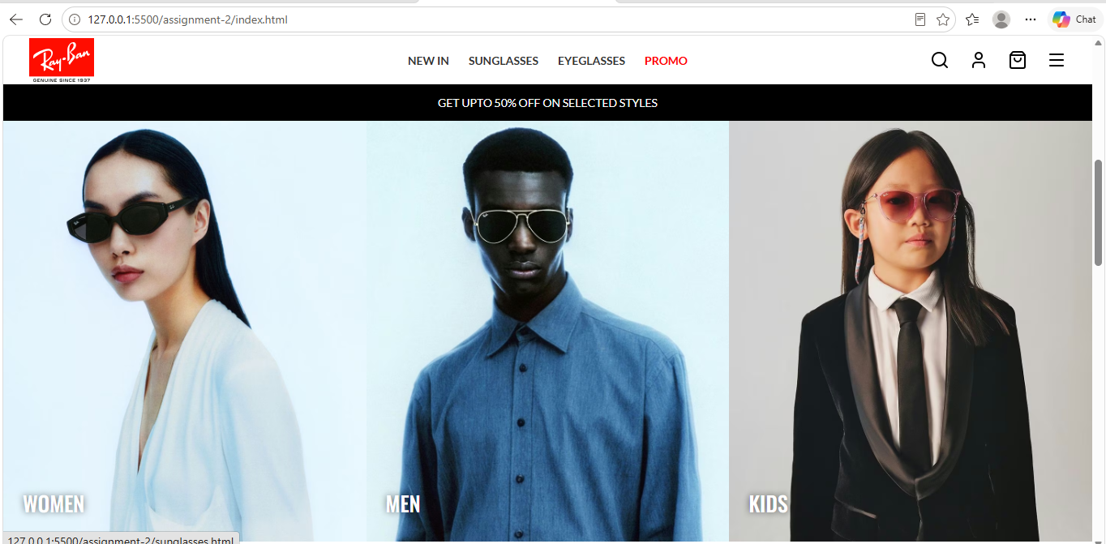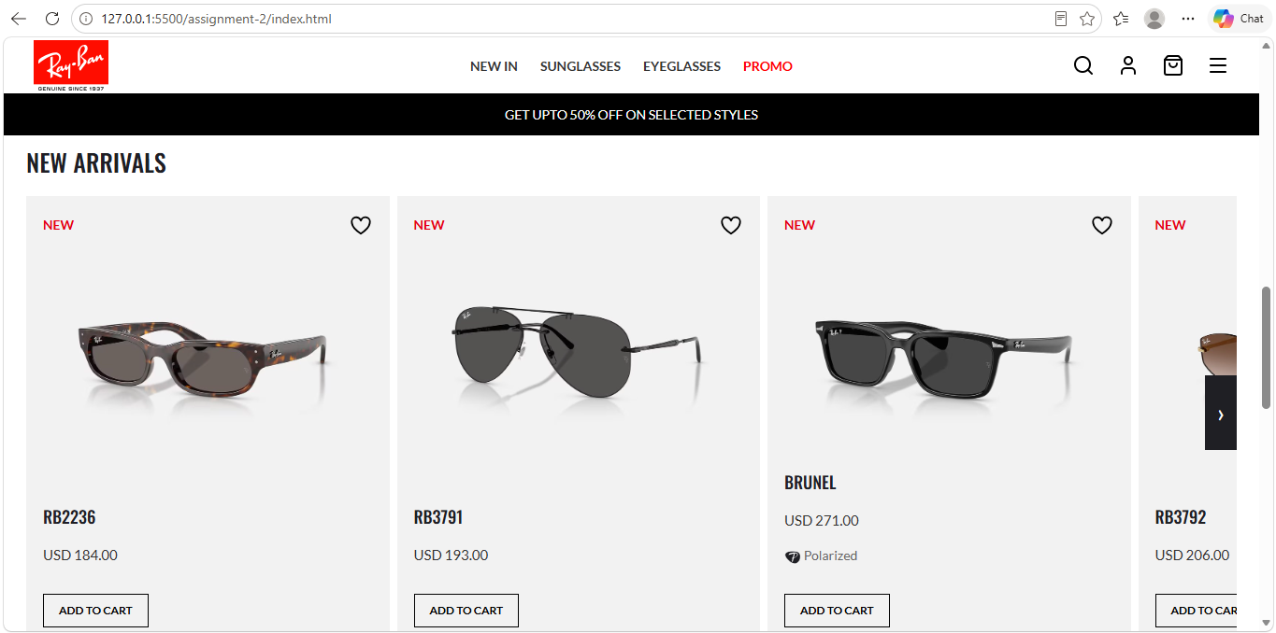
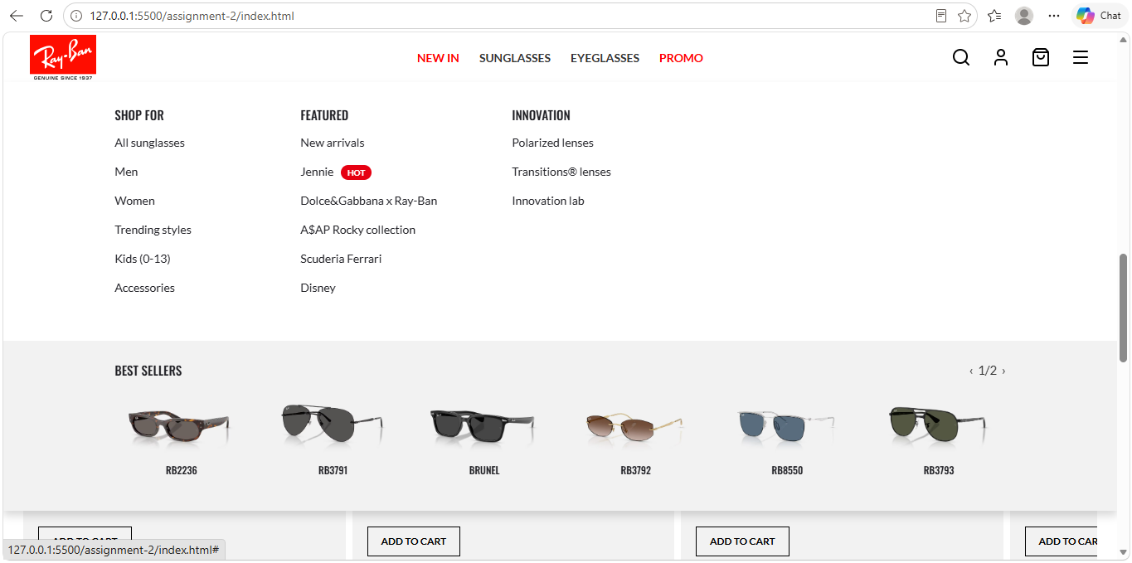
Product Page: 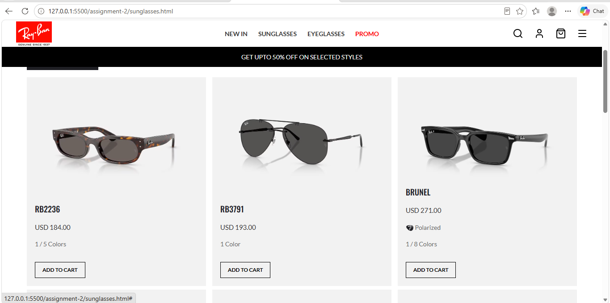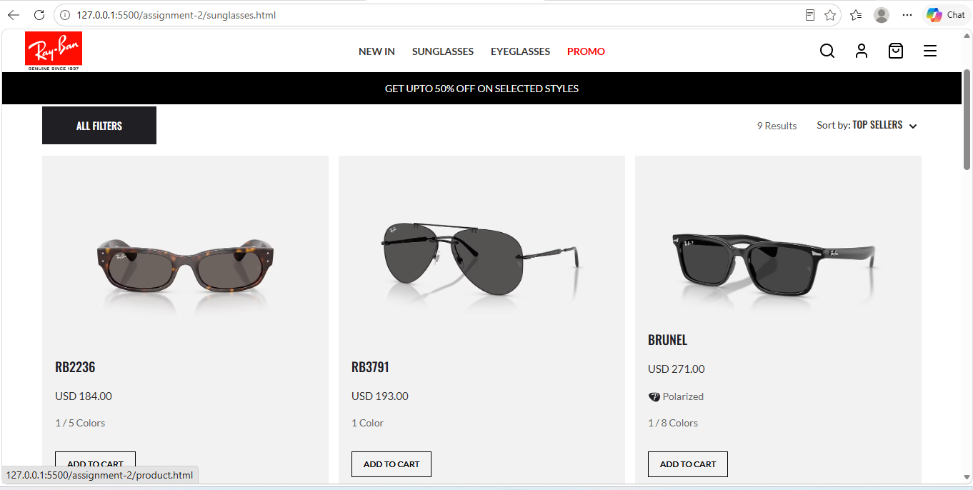 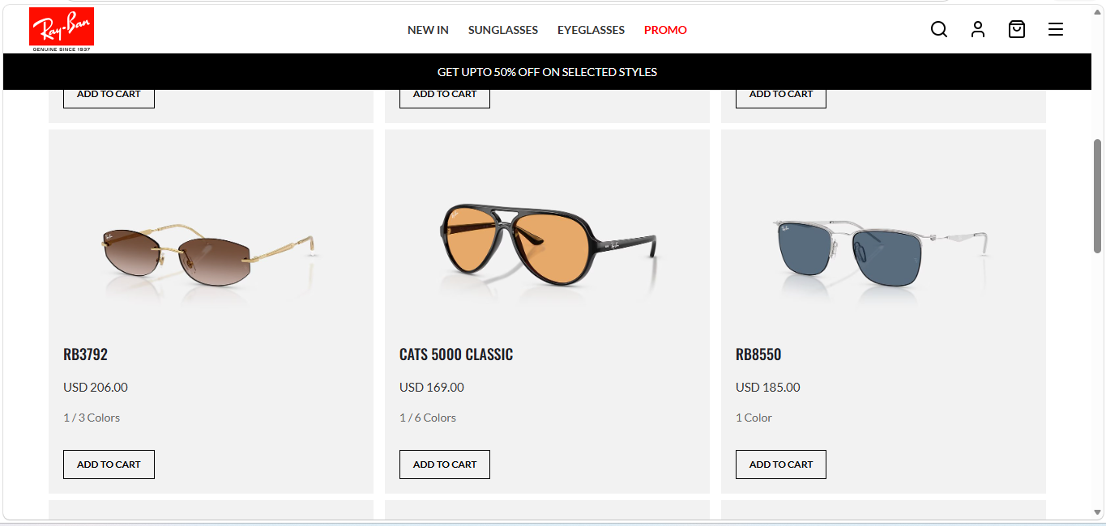

Different Dimensions:
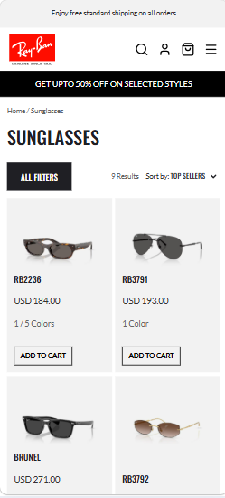
1Phone
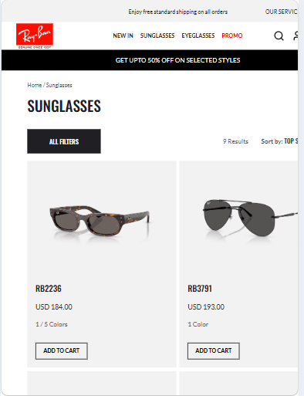
2ipad
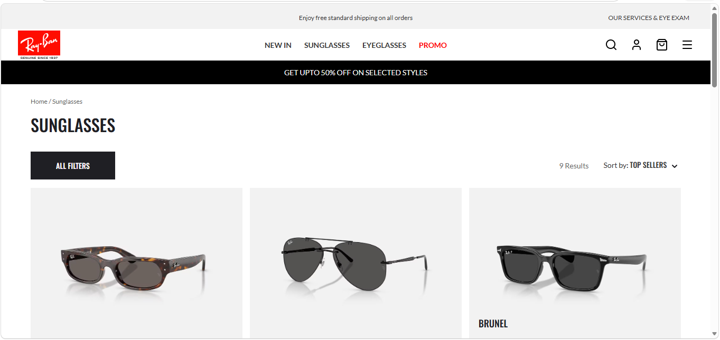
3Desktop

